**Project Tracing Tools**

Trying to manage a project without project management software can turn into a Godzilla-like apocalypse quickly.

Even with the best intentions and strategy, a wrong turn can quickly demolish months of work, and a misstep can mean the small-business equivalent of losing San Francisco. Taming this project gone bad can be a horrific task—especially when you have to pay a lot of money to do it.

Fear not.

Small businesses have a variety of possibilities for organizing their projects from the deep. And the best part? All of these options are free.

**Pros**

BamBam! is optimized for Agile development. It offers time tracking, issue tracking, and does not limit storage. It integrates with other 84Kids (BamBam!’s parent company) applications, including Chime for time tracking and Springloops for code hosting and deployments for web developers.

BamBam! also offers top of the line SSH performance encryption–it brags, “BamBam! has never recorded a single case of data loss since the suite launched in 2006.” Finally, BamBam! offers user permissions and allows project managers to invite clients to view the progress on their projects.

**Cons**  
BamBam! is specifically designed for Agile, so there isn’t any functionality for any other project management method.

[**8. Bitrix24**](http://www.bitrix24.com/)

Bitrix24 is a project management system entirely free for up to 12 users, with an option to upgrade to more for $99 per month. The features rival those of PM’s current go-to software: BaseCamp.

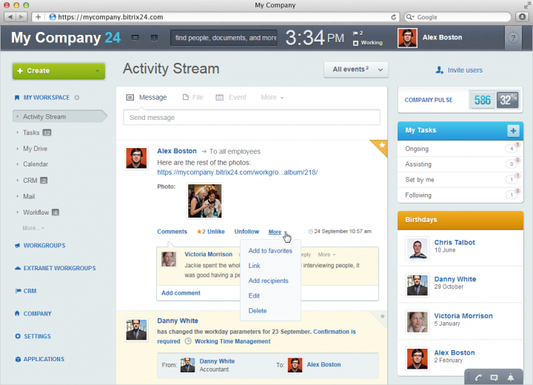

**Pros**

Users can choose whether to use Bitrix24 in the cloud or self-host on the company’s own server. The PM features are outstanding: Bitrix24 offers Gantt charts, layered task options, time tracking and management, and even employee workload planning.

Bitrix24 also makes real-time communication a breeze with group chat, videoconferencing, and instant messenger. It also acts as a [DropBox](https://www.dropbox.com/business/business-free-trial?_tk=sem_goog_b&_kw=dropbox|e&_net=g&_ad=35064061902|1t1&_camp=sem_google_b_dropbox_us-english&gclid=CLTAppKWz74CFZBxOgodK2QAKg" \t "_blank) alternative—the free version offers 5GB of cloud storage for easy document sharing—and, for just 25¢ a month, businesses can add an additional gigabyte.

In addition, recent updates include:

* An Employee Workload Planning tool that lets managers plan certain number of hours for a task and then compare it with the number of actual hours spent by those who the task were assigned to.
* The ability to make task templates that contain subtasks and checklists.

**Cons**

Small businesses may struggle with the free version of Bitrix24 solely because of its limitation on user profiles—and the jump to $99 per month may be a non-starter if you’re cash-strapped. Right now, Bitrix24 does not allow task dependencies or an automated way to create invoices, but these features are slated to be released in Fall 2015.

[**7. Trello**](https://trello.com/)

Trello uses a method called [Kanban](http://en.wikipedia.org/wiki/Kanban_%28development%29), a project management system developed by a former Toyota vice president, Taiichi Ohno, which allows users to move cards—representative of tasks—to create a visual representation of where a project is in development.

Trello offers unlimited users and projects, but only offers 10MB of storage on their free version. Luckily, it’s easy to get Trello Gold–just share and get a new user on board, and you’ll jump up to 250MB for a year. Looking to pay for it? It’s only $5 a month, or $45 for a year.

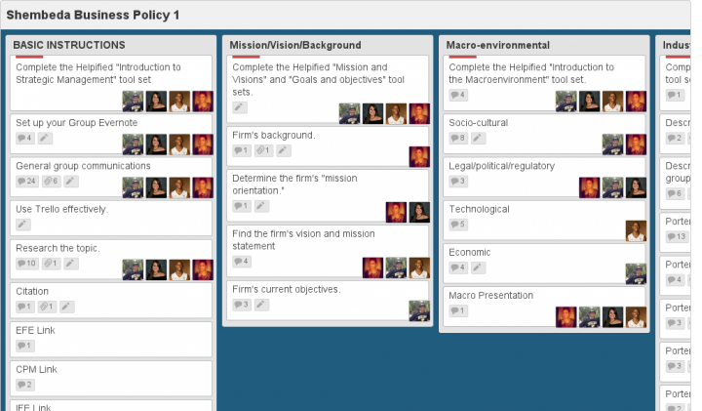

**Pros**

If a more intuitive project management software option exists than Trello, [I’ll dress up as a burrito and beg for free Chipotle](http://blog.capterra.com/top-8-freeopen-source-lmss/).

A quick peek at the alignment of the cards lets users know how far along a project is—and what to work on next. While the front of the card has little more than a task label, the back can be filled with all kinds of information—like who’s working on the task, when it’s due, and what parts of the task have already been completed with a simple checklist. Trello also now offers a calendar function so everyone can collaborate on their projects transparently.

**Cons**

Because of Trello’s emphasis on simplicity, it’s missing a few key features. There isn’t a good way to look at a project with high detail—for example, it does not offer an option to see task lists broken down by user or due date.

[**6. 2-Plan Project Management Software**](http://2-plan.com/)

From the glut of open-source software, 2-Plan stands out. The system has three symbiotic programs—all free:

* 2-Plan Desktop, a project-management system.
* 2-Plan Team, a web-based project management tool with multiple hosting options.
* Work 2-gether, a Scrum-based task management board for one-team projects.

All of these options are free, but you may choose to pay for additional extensions.

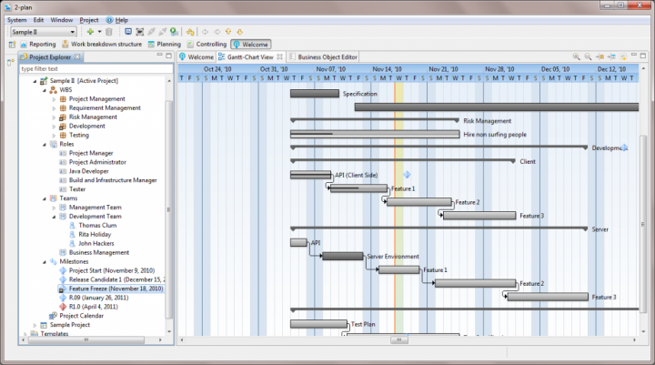

**Pros**

2-Plan is a behemoth when it comes to features. On the desktop version alone, project managers can create an animated graphical WBS, craft project milestones,implement top-down and bottom-up planning, and build project control systems.

2-Plan Team makes it easy to coordinate with off-campus teams and track time spent on tasks—and it integrates seamlessly with 2-Plan Desktop. Work 2-Gether is similar to Trello in that it uses the Kanban system, but it also has the ability to expand into a greater workchart.

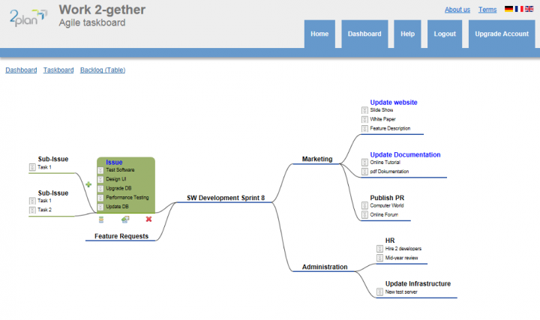

**Cons**

2-Plan offers a lot of features that can quickly get overwhelming for teams with little time for their extensive manuals. Furthermore, the free option can be limiting. Work 2-gether, for example, [only permits businesses to use two taskboards for free](http://2-plan.com/scrum-taskboard-online-work-2-gether-team-tools/103-upgrade.html) and team size is limited to three.

Thankfully, its pro accounts are reasonably priced—businesses only have to pay $15 a month to fully upgrade Work 2-gether.

[**5. Asana**](https://asana.com/)

Based on their 40,000 customers and 400,000 users, Asana is one of the most popular project management apps available—and best of all, for up to 15 users, it’s free.

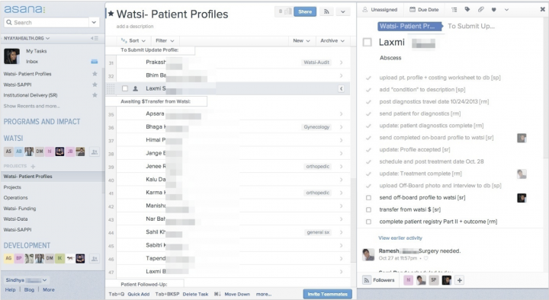

**Pros**

Dustin Moskovitz, the co-founder of Facebook, also designed Asana. True to the aesthetic and simplicity of the most popular social network, Asana is an intuitive task-management system that works best for teams seeking real-time interaction.

Asana allows its users to visualize their goals, track their time, assign priority to their tasks, and get updates on the project right in the program. It also has a calendar function to graph the team’s tasks right onto the dashboard.

In addition, over the past year, it’s added an Android app, the ability to convert a task to a project, conversations, and dashboards. It’s been beefing up–last year, its biggest con was that it didn’t have enough features.

**Cons**

Asana does not allow offline use. In addition, reviewers feel that “sometimes it is not intuitive enough to find something.”

[**4. MeisterTask**](http://www.meistertask.com/?r_campaign=capterra_free-open-source-project-management-software/)

I discovered MeisterTask when looking up underground free project management tools, and it’s a great little find. It offers unlimited users and projects, has native apps for iPhone and iPad, and gives free users two integrations (like with Dropbox,GitHub, Zendesk and Google Drive).

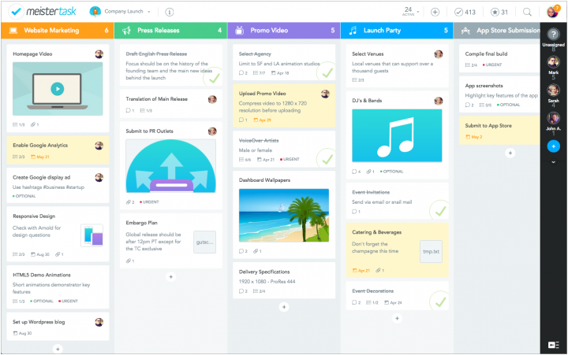

**Pros**

MeisterTask has all the important features: it offers time tracking, issue tracking, and collaboration with both internal and external users. There is *no*storage limit, so exchanging files is hardly a burden on the system’s capacity.

MeisterTask’s project boards are perfectly suited for various agile methodologies. The boards are completely customizable so that teams can create anything from Kanban to Scrum and various mixed forms.

Finally, the layout is just gorgeous to look at. Communication is a breeze–it’s similar to the conversation system on Trello, except with instant updates.

**Cons**

MeisterTask is still a new-ish project management system, so it’s working on a lot of projects that haven’t been launched yet. This includes:

* Gantt charts
* CCPM
* Integration with Toggl
* Android app (to be released in Fall 2015)

[**3. GanttProject**](http://www.ganttproject.biz/)

GanttProject is another open-source free project scheduling and management tool.Reviewers have compared this heavy-hitting application to Microsoft Project—both in terms of features offered and complexity. This system can generate Gantt and PERT charts, produce reports in HTML and PDF formats, and offers versatile scheduling and time management tools.

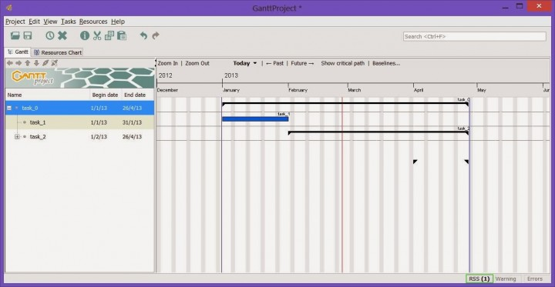

**Pros**

There is no limit to what you can do with GanttProject. The management platform allows users to quickly create a structured schedule for any project. It offers task assignment and milestone implementation. The open-source software also enables project managers to identify problem areas in the workflow so that companies can set goals for improvement.

**Cons**

I would not recommend GanttProject to people who are unfamiliar with project management software.

[**2. Producteev**](https://www.producteev.com/)

Producteev offers its clients unlimited users and projects for free—and unless your small business needs Outlook integration, personalized support, or visual customization, there’s no reason to upgrade to Pro.

Among its many features, it permits users to create tasks that belong in multiple task lists, offers real-time communication between users, features results measurement and progress tracking, and lets users turn emails into tasks with a few simple clicks.

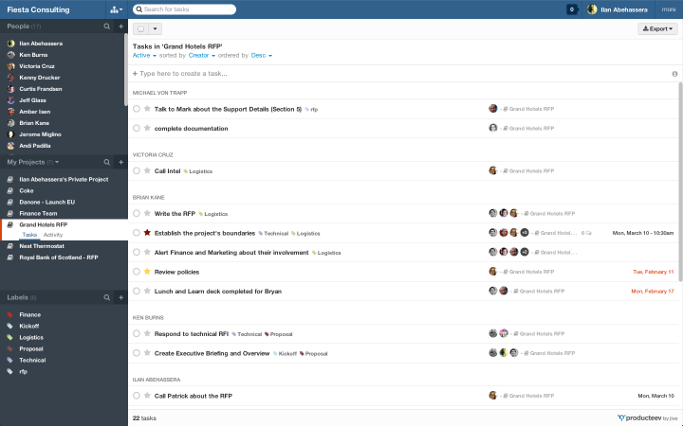

**Pros**

Producteev is incredibly easy to maneuver—almost every function that Producteev offers is self-explanatory. It can filter tasks by people, project, status, due date, priority and more. The application also offers simple file sharing through attachments or DropBox.

**Cons**

Producteev has few drawbacks. Some missing features—like time tracking and integrated billing software—may be unfavorable.

[**1. Freedcamp**](https://freedcamp.com/?ref=capterra)

Unlimited users.

Unlimited projects.

Gorgeous design.

Innumerable functions.

Optimized for communication.

Kanban or tasks–you choose.

200 MB of storage–upgrade to 1 GB for $2.49 a month.

Freedcamp has truly earned its #1 spot on this list.

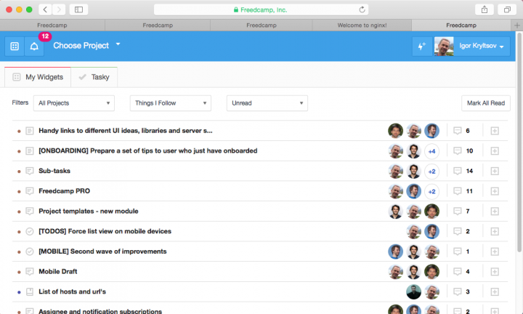

**Pros**

Freedcamp is great for businesses who want to be able to scale with their project management software; the free version will last your company for a long while, and upgrading is cheap, cheap, cheap. For example, add-on components range from $2.99 for GoogleDrive integration to $12.99 for CRM. Storage upgrades are available from $2.49 for 1GB.

The free version can certainly hold its own though.

Administrators can limit different users’ permissions right down to the client level. Freedcamp also offers time tracking, templates, and invoicing.

Its collaboration features are awesome. Users will never be behind because Freedcamp makes sure to add notifications everywhere when there’s an update (and they’re innocuous, like a Facebook notification, so they don’t get in the way). There is no mobile app, but Freedcamp has optimized its website for mobile use.  
**Cons**

Reviewers have claimed that there is a small learning curve on site navigation. Others have noted that they are unable to save multiple milestones at once. In addition, there is no mobile app as of now, but the company is planning to launch an app for iOS soon. There are some missing features as well, including Gantt charts, task dependencies, recurrence, and subtasks.